# CTI 110

# P2LAB1 – Uploading Files to GitHub

One of your final Course Projects will be your Python code portfolio, hosted on GitHub. In order to receive full credit, you will need to upload each Python program you write to your CTI110 repository. This tutorial explains that process.

# **Lab Background**

In this assignment, you will create an online source code repository. There are a number of source control / version control systems available to developers. One popular system is GitLab, which uses a tool called git.

This system allows you to store and share your source code online through a website. This tutorial assumes you’re using **GitHub, which is a popular GitLab-based site**. (If you wish to use another GitLab site instead, get permission from your instructor.)

Your submission will consist of a URL which the instructor can access to check your work.

**NOTE: Over the course of the semester, you should continue adding your completed Python programs to this repository to build a portfolio of work.**

# **Lab Assignment Creating your GitHub account**

GitHub offers free and paid accounts. You will be creating a **free account**. (Paid accounts add extra features we have no use for; you will be able to do anything you need to do on a free account.)

Go to <https://github.com/>

(opens in a new window)

and **create a new account**. Use your FTCC student email when prompted for your email address. You may use a username of your choice, or your FTCC login name.

Check your student email for a **confirmation email**, and follow the link provided there to activate your account. You should now be logged into GitHub.

# Creating a Repository and Uploading Code

**1. Create the CTI110 repository**.

Make sure you check “Initialize this repository with a README”.

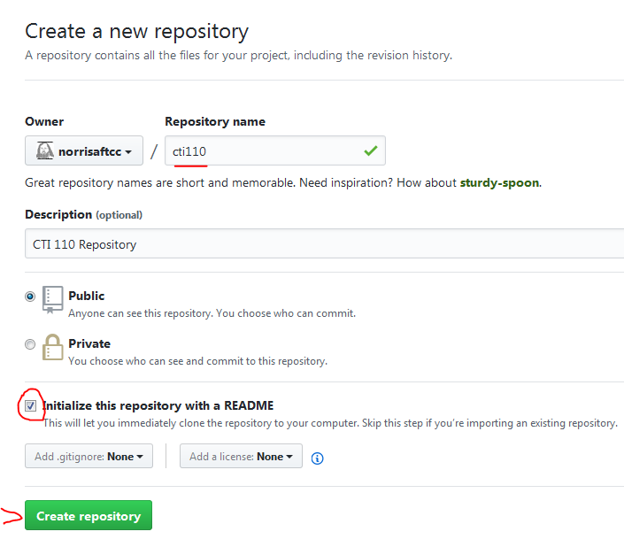

**2. Edit the README.md.**

You should now be looking at a new empty repository.

Click on the README.md file in the file list (it should be the only file there).

Next, click the edit button (to the right of the filename, looks like a pencil) and enter the following:

# CTI 110 Repository

Created for P2LAB1

Last name

Date

Use your actual name and today’s date. Save your changes.

**3. Locate the file you want to upload**

We will be using P2T1_LastnameFirstname.py from your local file system. (Assuming you’ve completed that assignment. If not, do that first.)

I recommend keeping all your course files in one place and organizing them by course and by module. (For example, if your flash drive was mounted as the E: drive, you might find your file at e:\cti110\p2\p2t1_lastnamefirstname.py).

My file was located at c:/courses/17su/cti110/_sandbox/P2T1_norrisa.py for example.

4. **Upload your file** to your CTI110 repository.

We will use the website interface. (For other methods, see Appendix A at the end of this document.)

Click the “Upload Files” button.

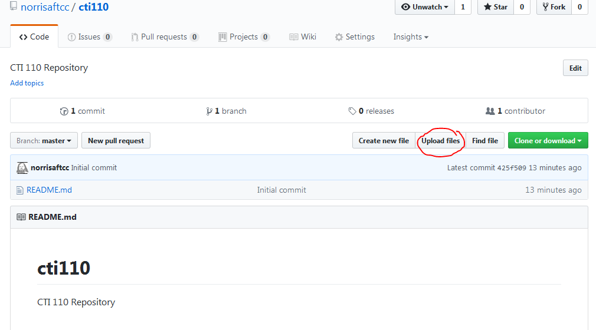

The page will now prompt you to upload your source file. Either drag and drop, or click “choose your files” and use the file browser to upload the file M1T1_Lastname.py.

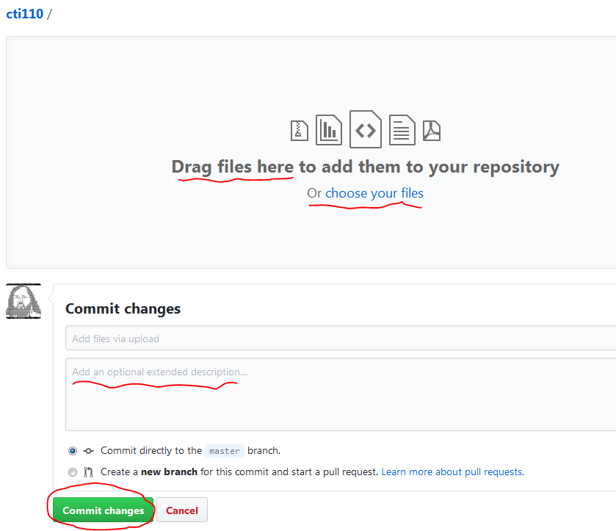

Whenever you add or update a file, you should add a commit message, even if it’s just something like “First submission”. You have to fill in the first box, and the second box is optional.

If you upload the same file again, GitHub will track what changes where made and when – listing a meaningful comment on each commit will help you in the long run. (It will also show potential employers that you know how to properly use git.)

Finally, commit changes using the “Commit Changes” button.

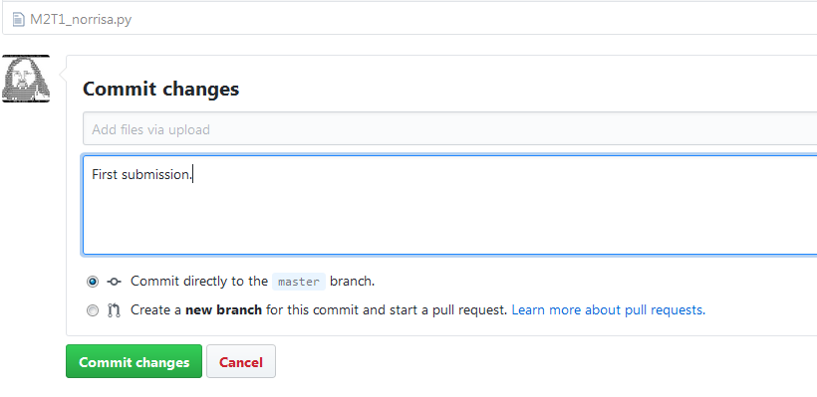

**5. Finish the tutorial**. Confirm that the file is in your repository, locating its URL on GitHub, and submitting that URL.

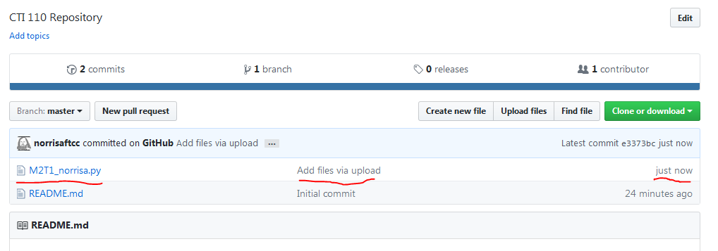Khttps://github.com/dumbuyaf3288/cti110/blob/master/P2T1_Salesprediction_DumbuyaFatmata.py

Navigate to the file itself. When it opens in GitHub, take note of the URL in your browser’s address bar. (For example, mine is located at <https://github.com/norrisaftcc/cti110/blob/master/M2T1_norrisa.py> )

(opens in a new window)

This is what it looks like on my system.

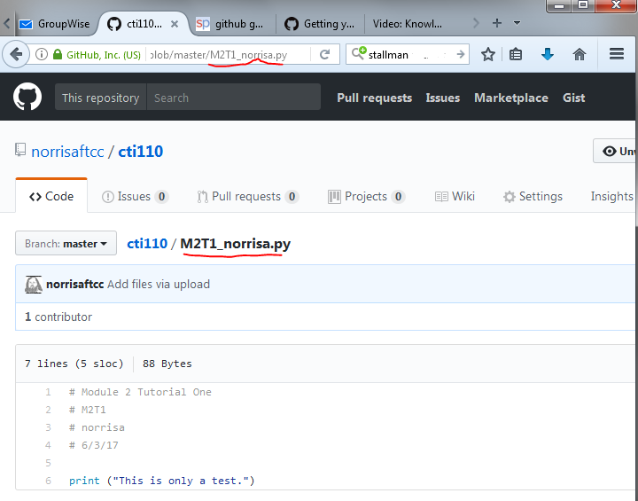

Your URL will look something like

<https://github.com/UserName/cti110/blob/master/M2T1_lastname.py>

<https://github.com/dumbuyaf3288/cti110/blob/master/P2T1_Salesprediction_DumbuyaFatmata.py>

(opens in a new window)

In order to complete this assignment, copy and paste the URL as a written submission.

**You should get in the habit of updating your portfolio whenever you turn in a new program to Blackboard.** Whenever you write a new program, be sure to upload it.

# Appendix A: Other Upload Methods

This tutorial assumes you will use the GitHub website to directly upload files. This is only one possible method.

**Other GitLab sites:** The GitLab company itself hosts an installation that works the same way as GitHub. Many others exist, and some companies host their own internal installations.

**GitHub Desktop:** Some find the GitHub Desktop application more convenient. Full directions are found at <https://guides.github.com/introduction/getting-your-project-on-github/>

(opens in a new window)

**Visual Studio:** Microsoft Visual Studio can interface with GitHub using a plugin.

**git:** The command line tool git can be configured for use with GitHub. This is recommended only for advanced users.